Neighborhood Homes Initiative
Hiawatha, Mattapan, Fottler & Walk Hill Sites
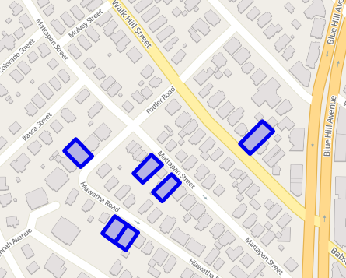
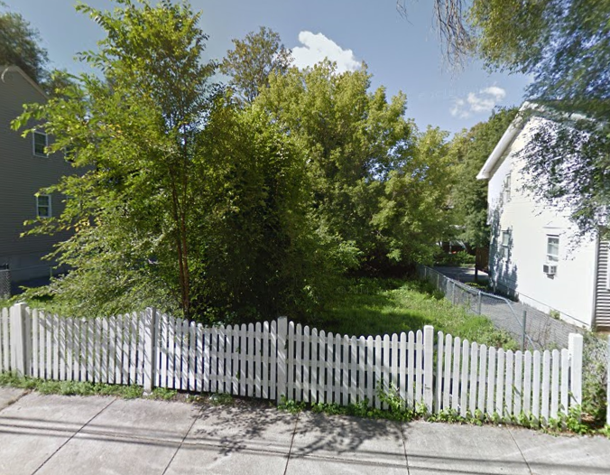
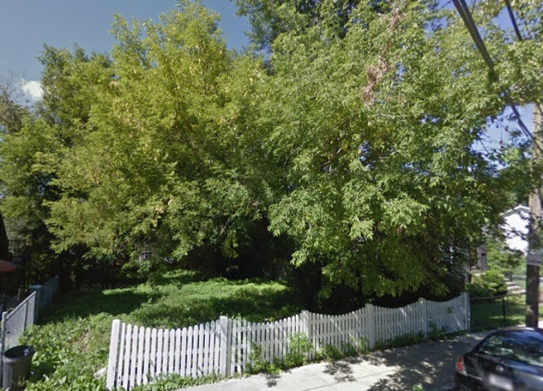
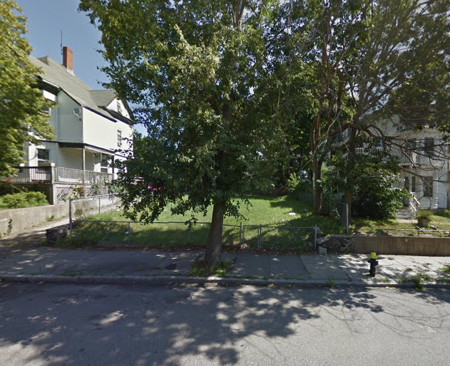
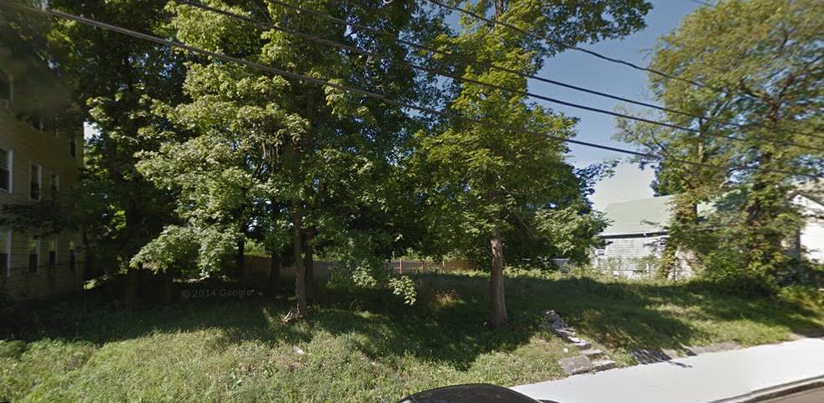
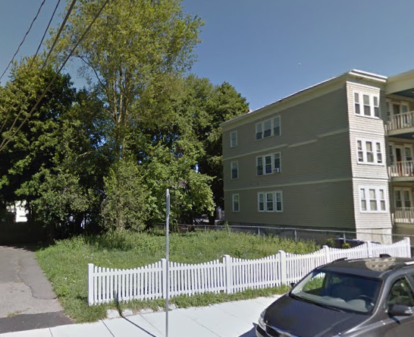
Site 3: 48, 56 Mattapan
Site 2: 698 Walk Hill

Site 4: 58, Adj. 58 Hiawatha
Site 1: 53 Fottler

SITE 1: 53 FOTTLER ROAD
Home Model: 2-Fam Model H Flat
Special Design Modifications: Architectural details and siding composition are to be enhanced to further relate to the details of triple decker styled homes on the street.
Site Preferences/Parking: Access location of curb cuts due to existing street elements. The preference is not to have curb cuts next to one another as shown.
 | 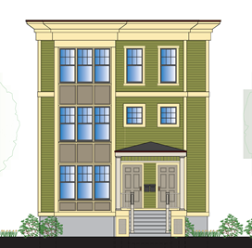
SITE 2: 698 WALK HILL STREET
Home Model: 2-Family Model B
Special Design Modifications: Architectural details and siding composition are to be enhanced to mirror period details of existing homes on the street.
Site Preferences/Parking: Access location of curb cuts due to existing street trees and fire hydrants. The preference is not to have curb cuts next to one another as shown.
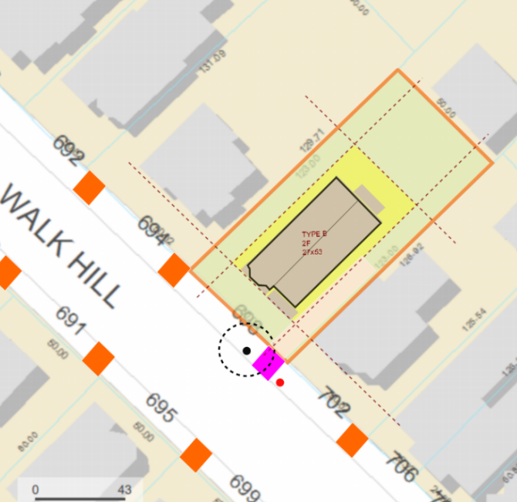 | 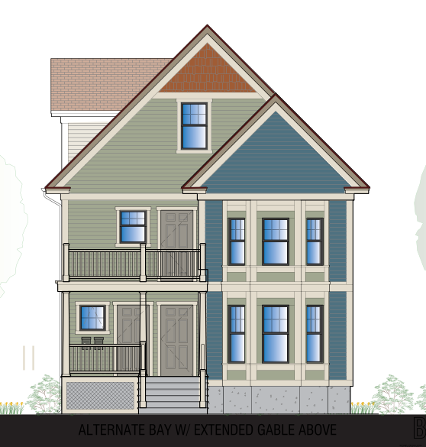

SITE 3: 48, 56 MATTAPAN STREET
Home Model: Two 1-Family Model A2 Homes
Special Design Modifications: Primary front entrance is to be modified to face the street. Architectural details and siding composition are to be enhanced to mirror period details of existing homes on the street.
Site Preferences/Parking: Access location of curb cuts due to existing street elements. The preference is not to have curb cuts next to one another as shown.
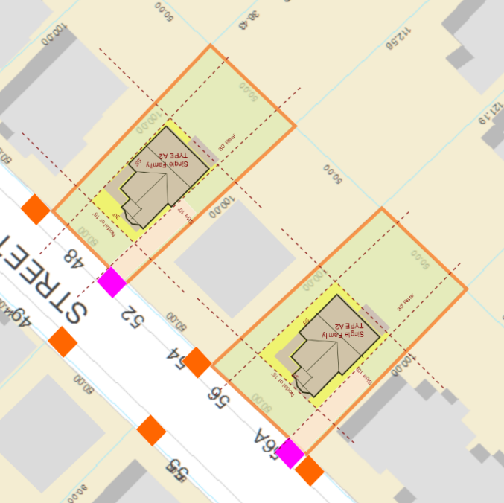 | 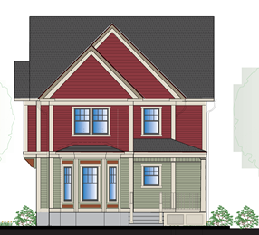
SITE 4: 58, Adj. 58 HIAWATHA ROAD
Home Model: Two 1-Family Model A Homes
Special Design Modifications: Architectural details and siding composition are to be enhanced to mirror period details of existing homes on the street.
Site Preferences/Parking: Retaining walls may be required at front edge of the property to be consistent with adjacent properties. The preference is not to have curb cuts next to one another.
 | 