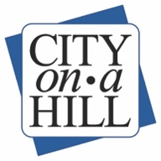

COAH Governance Committee Meeting Notice
Posted June 24, 2020

Notice
The City on a Hill Charter Public Schools Governance Committee will be meeting on Friday, June 26, 2020. The meeting will be held at remotely at 3:30 pm. The Zoom link is https://us02web.zoom.us/j/82052093281, and the call in number is 646-558-8656 and the passcode is 820 5209 3281.

Agenda
- Opening Items
- CoaH CS Renewal, Boston Consolidation, and CoaH NB Closure Update
- Board Growth and Onboarding Discussion
- SY2020-2021 Board of Trustees Events
- Closing Items

In accordance with the Americans with Disabilities Act (ADA), if any accommodations are needed or if you have any questions, please contact Jordan Pina at (617) 981-4350 or email jpina@cityonahill.org.

Requests should be made as soon as possible but at least 48 hours prior to the scheduled meeting.

