Attention: Nick Armata and Beacon Hill Architectural Committee
Submission Date: June 18, 2025
Property: 28-30 Mount Vernon Street, Boston MA 02108

This is an emergency request for review and approval of plans to rebuild 2 chimneys at 28-30 Mount Vernon Street in Beacon Hill.
There are 4 condominiums in this association. 2 of the 4 chimneys have been found to be structurally deficient and are being demolished. The chimneys were falling away from 26 Mount Vernon and were in danger of collapse. This requests approval for our plans to rebuild these 2 chimneys.
We propose scaffolding the front of the building and protecting the sidewalk of Mount Vernon Street in order to access the façade, roofs and chimneys with workmen and materials. We expect the work can be completed within 6 weeks.
We will duplicate the color of the existing grout on the façade and chimneys, and we will do our best to use bricks salvaged from the demolition of the chimneys. We are not requesting any changes to the height or width of the chimneys, but the depth (projection off the wall) should be reduced from roughly 21” previously to 12”. This will allow for a structurally sound repair, fully supported by the adjacent party wall and an existing wall underneath.
There is a building permit in place for this overall project. This request is to amend that permit SF1707453 for this unanticipated work and revise the project cost upwards by $12,000. BHAC Landmarks has also already generally approved the wider scope for this permit as 25.0758 B.
Our project description upload on the portal reads as: Rebuild 2 chimneys at 28 Mount Vernon Street, along the party wall with 26 Mount Vernon Street, following their demolition in late May, early June 2025. We propose building back with brick from the original chimneys. We propose the same width and height, but the projection off the party wall will be reduced from 21” to 12” for safety and stability. These will not be functioning chimneys and are being replaced for the purpose of preserving the historic look of the buildings in the neighborhood. The chimneys are partially visible from Mount Vernon and Walnut streets. This work is part of SF1707453 and does not need a new permit but amends the amount of work cost and requires a new approval from BHAC

David Doyno
30 Mount Vernon Street
617-543-4204
Ddoyno@comcast.net

Photo evidence
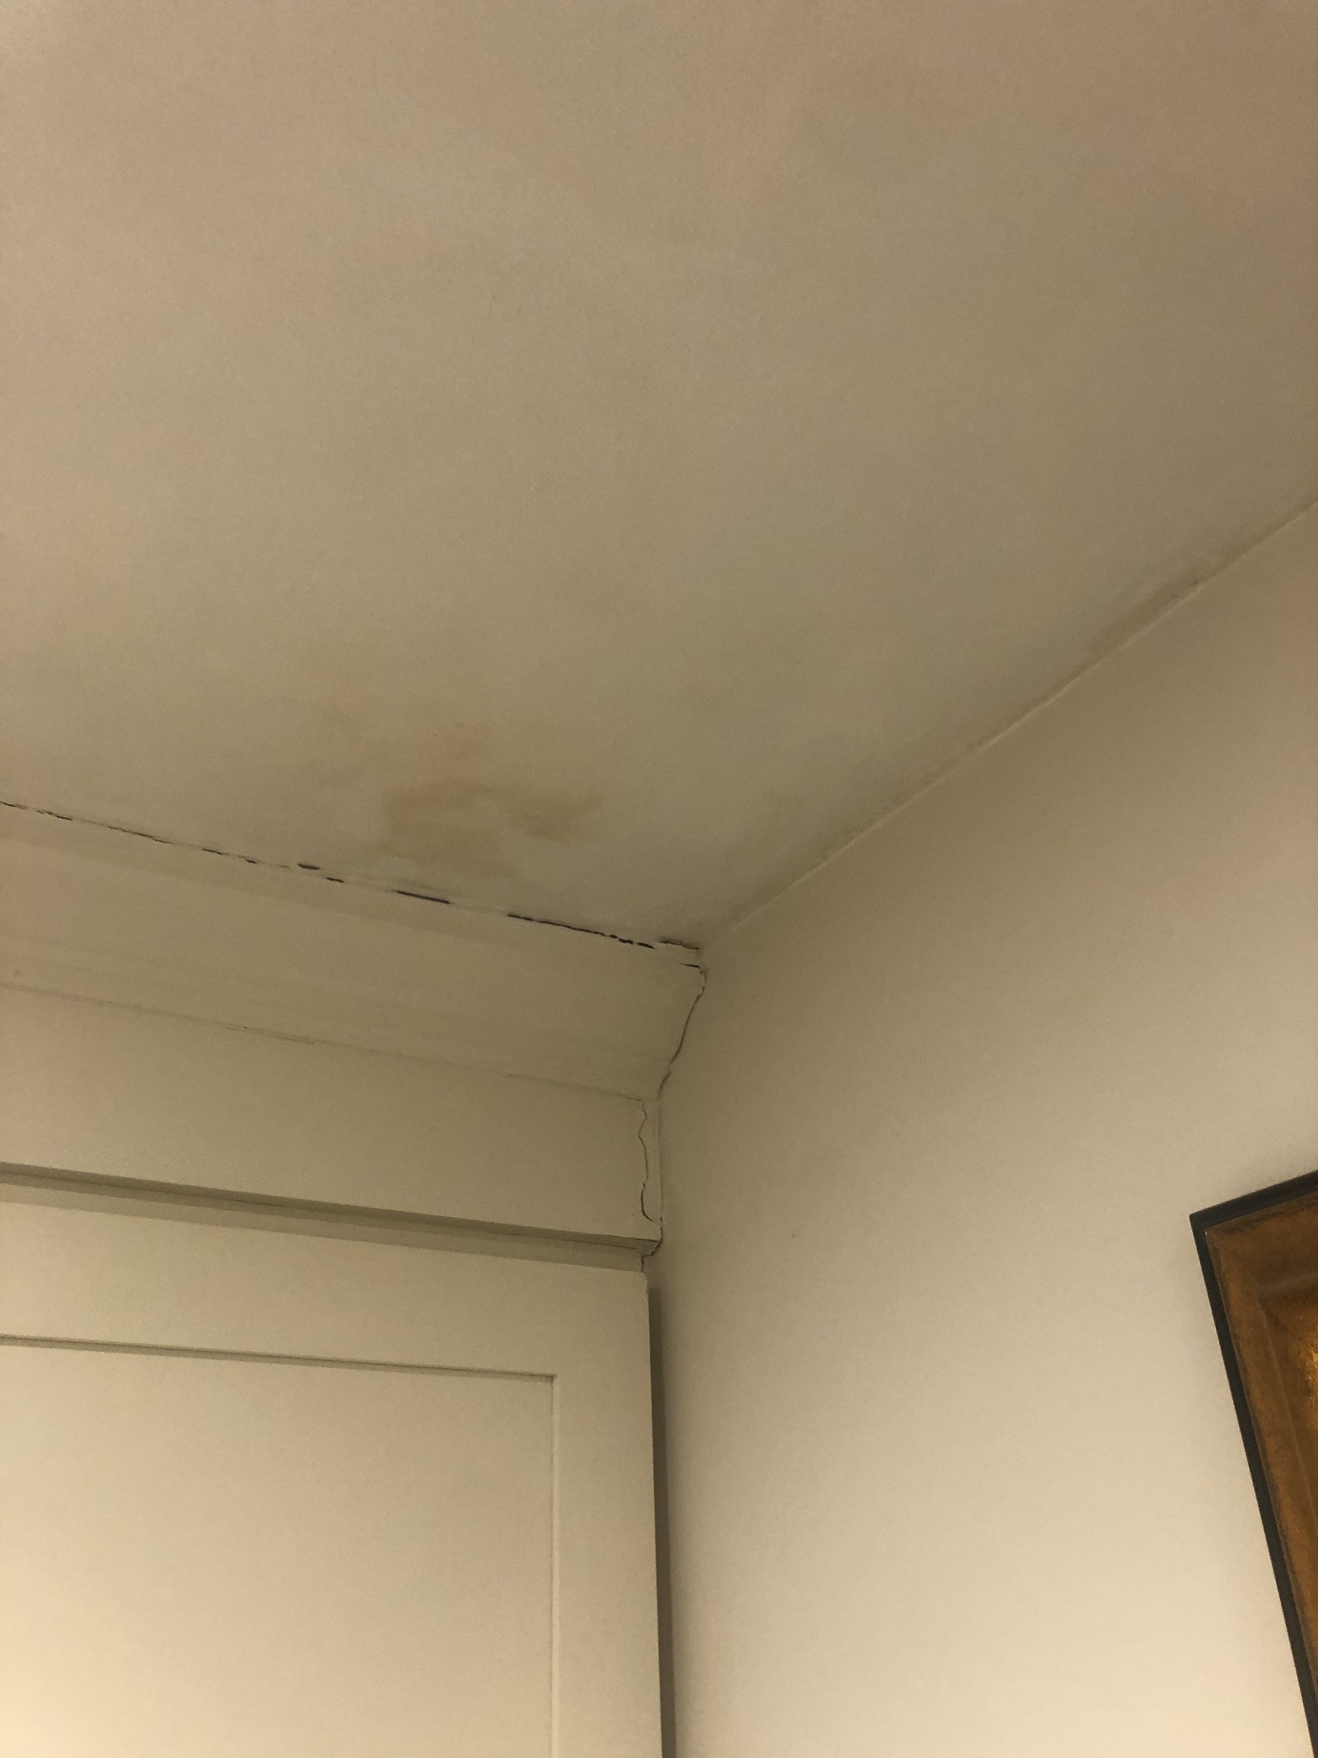
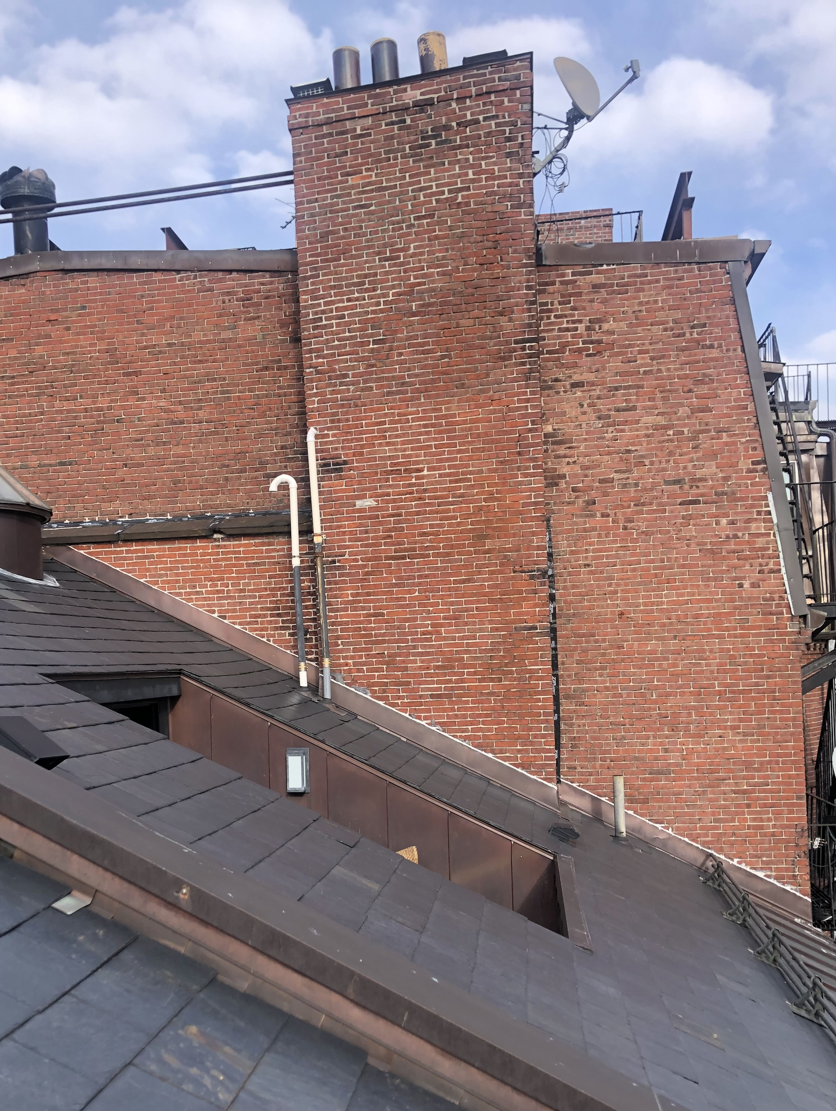
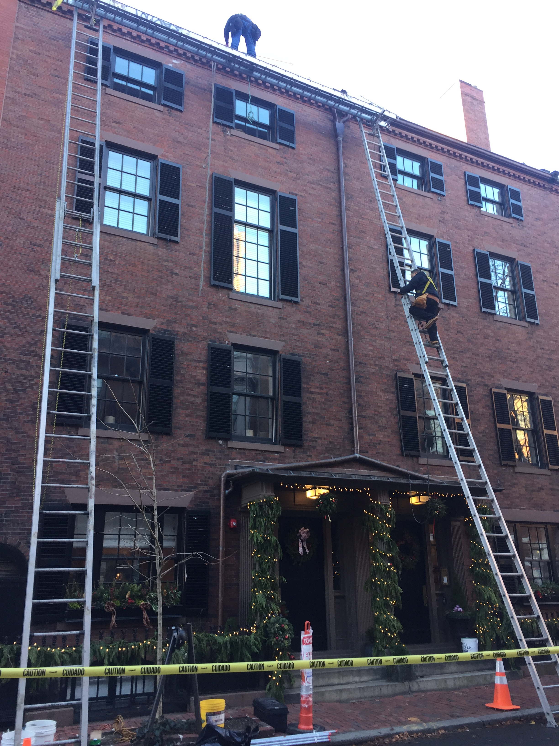
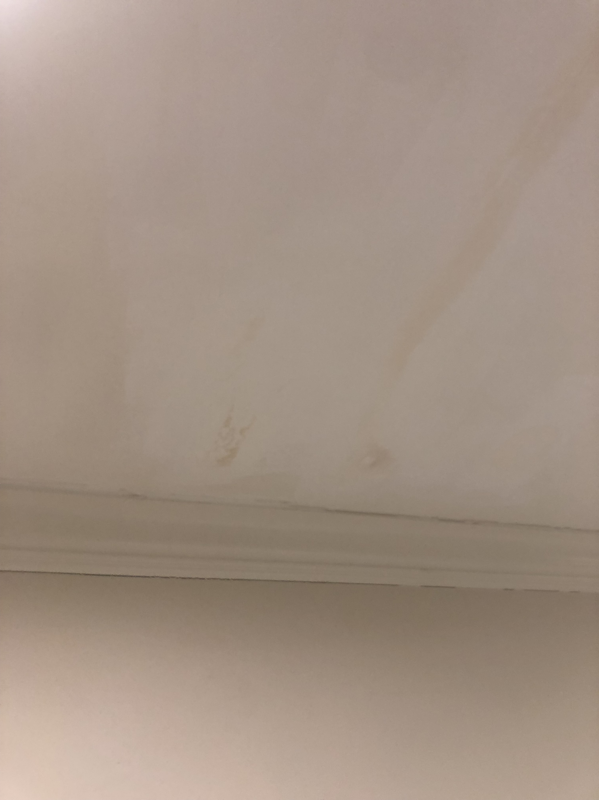
Front façade of both 28 and 30 Mount Vernon Street showing the number of shutters to be re-painted black (2020 picture, no work happening yet) and chimney empty joints and step flashing repairs needed.
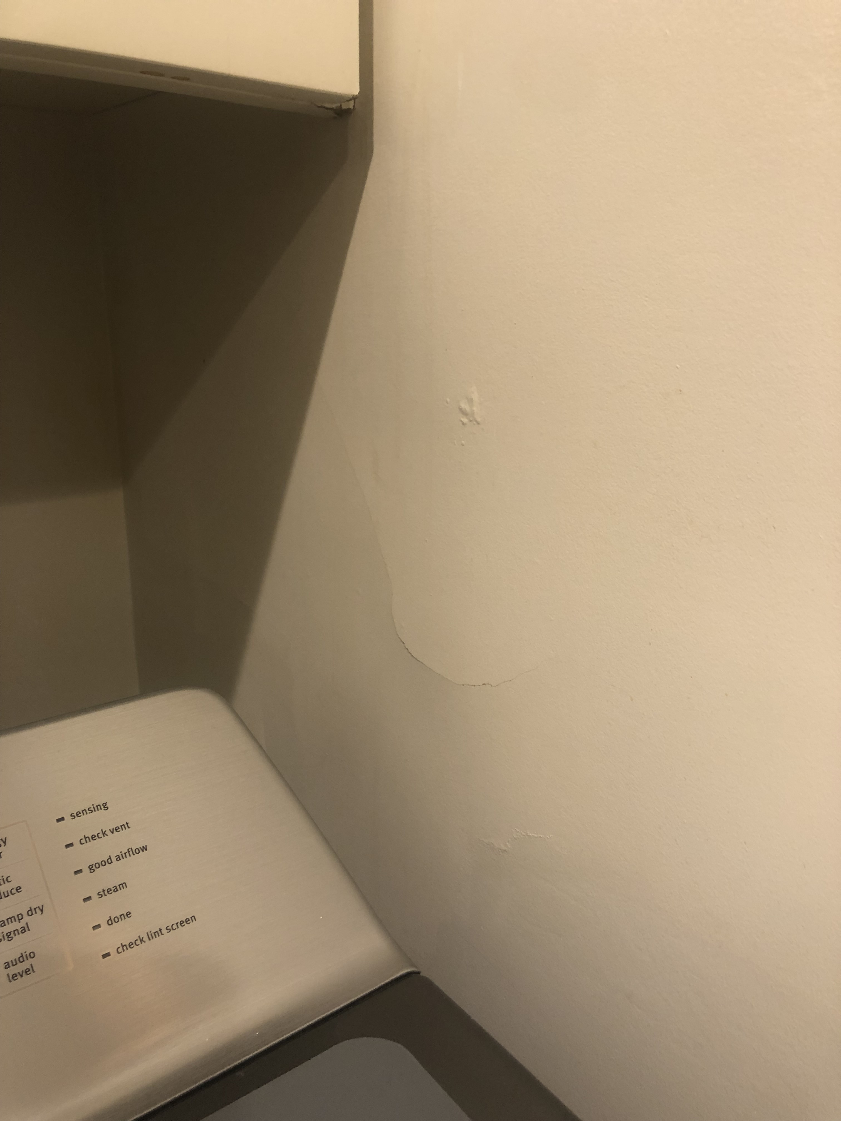
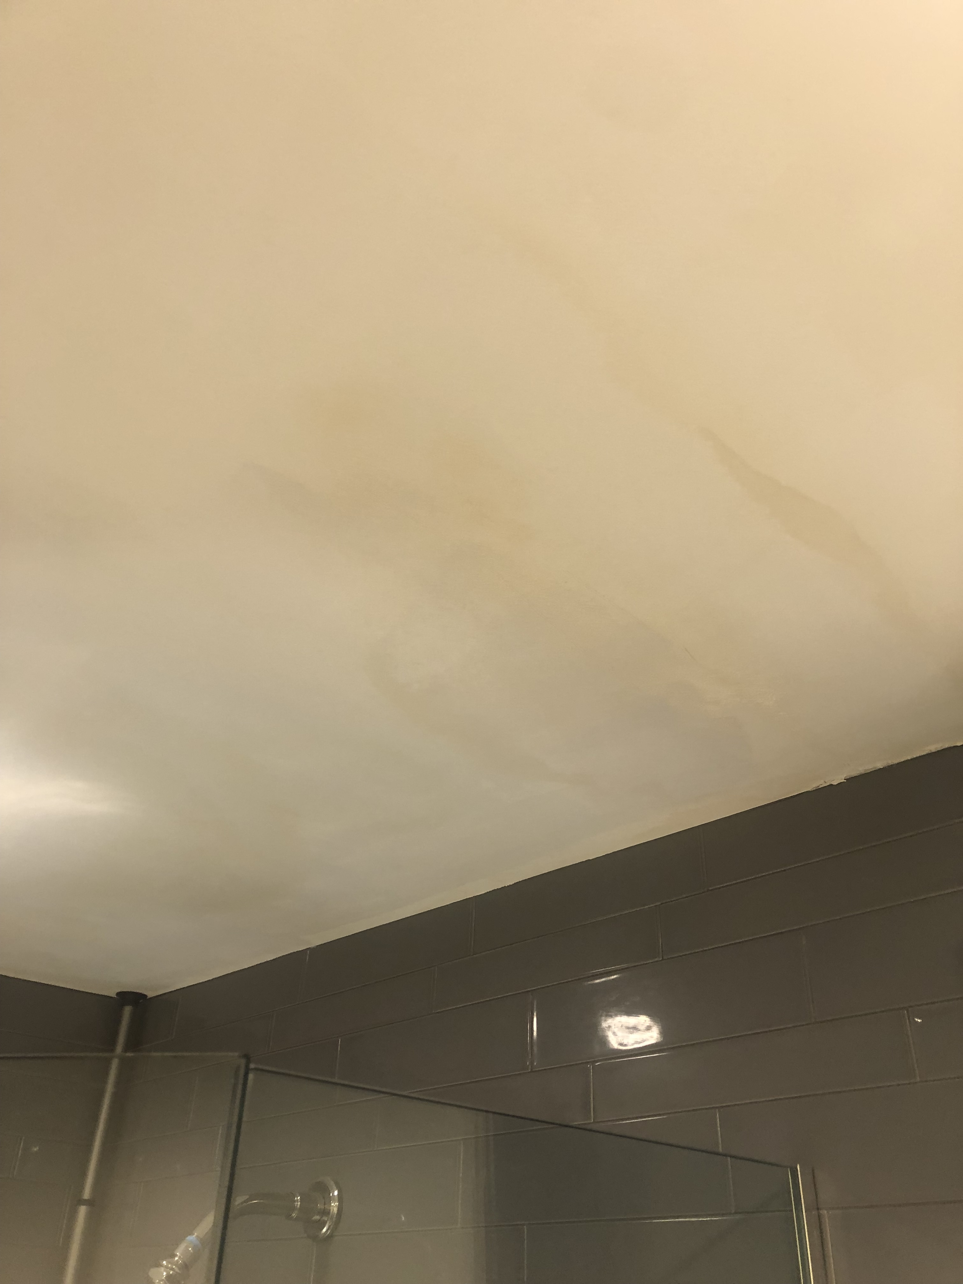
Water damage to walls and ceilings in 4 rooms at both front and rear of the houses near chimneys and party walls where missing step flashing and open brick joints were found

